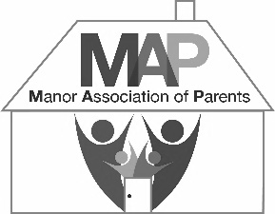
Manor Association of Parents
Second-hand Uniform Shop (SHUS)

SHUS Seller Registration Form

Please complete/tick all the fields and return to the Bursary team. If no seller registration information is held on file, 100% of sale proceeds will go to the Manor Association of Parents (MAP) fund. All money allocated to the MAP fund will be used on future projects that benefit pupils.

Child Surname |  | School Account No.*
Parent Name
Parent Email
*Please find this at the bottom of your school fee invoice emailed each term.

I agree to being paid 60% of sale proceeds and donating the remaining 40% to the MAP fund for as long as I have a child enrolled and/or for two years after leaving.
I will ensure that uniform submitted for sale is clean, in good condition, has had name labels
removed and are individually tagged as required, failing which my items may be rejected.
I accept that any unsuitable uniform will be rejected and recycled without notice.

Important: Please provide your bank details for payment after leaving.
Sort Code |  | – |  | – |  | Account No
Account Name

Payment Terms
I understand that by signing below, I agree that while my child is enrolled, any payments due will be credited to my school account as provided above. Within two years of my child’s leaving date, any proceeds due to me will be paid by bank transfer. Thereafter, 100% of proceeds will go to the MAP fund. The minimum amount for payments to be credited or issued is £10.

Data Protection
I understand that by signing below, I agree to MAP keeping my details securely on file for two years after my child’s leaving date, after which this form will be destroyed. The Bursary team will have access to my details for the purpose of making payments and will comply with The Manor Privacy Notice, available on The Manor website. If my details change, I will submit a new registration form and the previous record will be destroyed.

Signature Date

For Official Use Only | Leaving Date: | Final Payment Date:

